**Chapter Title**

Authors’ names and emails

Authors’ affiliations

**Abstract**

Write the abstract of about 250 words. Full text about 8,000 words.

**1. Introduction**

Write the text of the Introduction. Use APA format to cite the bibliography. XXXXXXXXXXXXXXXXXXXXXXXXXXXXX XXXXXXXXX XXXX XXXXXXXXXXXXXXXXX XXXXXXXXXXXXXX XXXXXXXXXXXXXXXXXXXXXXXXX XXXXXXXXXXXXXXXXX.

XXXXXXXXXXXXXXXXXXXXXXXXXXXXXXXXXXXXXXXXXXXXXXXXXXXXXXXXXXXXXXXXXXXXXXXXXXXXXXXXXXXXXXXXXXXXXXXXXXXXXXXXXXXXXXXXXXXXXXXXXXXXXXXXXXXXXXXXXXXXXXXXXXXXXXXXXXX.

**2. Next headings**

Write the text. Use APA format to cite the bibliography. XXXXXXXXX XXXXXXXXXXXXXXXXXXXX XXXXXXXXX XXXX XXXXXXXXXXXXXXXXX XXXXXXXXXXXXXX XXXXXXXXXXXXXXXXXXXXXXXXX XXXXXXXXXXXXXXXXX.

XXXXXXXXXXXXXXXXXXXXXXXXXXXXXXXXXXXXXXXXXXXXXXXXXXXXXXXXXXXXXXXXXXXXXXXXXXXXXXXXXXXXXXXXXXXXXXXXXXXXXXXXXXXXXXXXXXXXXXXXXXXXXXXXXXXXXXXXXXXXXXXXXXXXXXXXXXX.

**Table 1.** Table title

|  |  |  |
| --- | --- | --- |
| **Abbreviation** | **Variable** | **Definition** |
| Xxx | Xxx | Xxxxxx |
| Xxx | Xxx | Xxxxxx |
|  |  |  |
|  |  |  |
|  |  |  |
|  |  |  |
|  |  |  |
|  |  |  |

Source: Xxxxx.

XXXXXXXXX XXXXXXXXXXXXXXXXXXXX XXXXXXXXX XXXX XXXXXXXXXXXXXXXXX XXXXXXXXXXXXXX XXXXXXXXXXXXXXXXXXXXXXXXX XXXXXXXXXXXXXXXXX.

XXXXXXXXX XXXXXXXXXXXX XXXXXXXXXXXXXXXXXXX XXXXXXXXX XXXXXXXX XXXXXXXXXXXXX XXXXXXXXXX XXXXXXXX XXXXXXXXXXX XXXXXXXXXXXXX XXXXXXXXXXXXXXX XXXXX XXXX XXXXXXXXXXXXXXXXXXX..

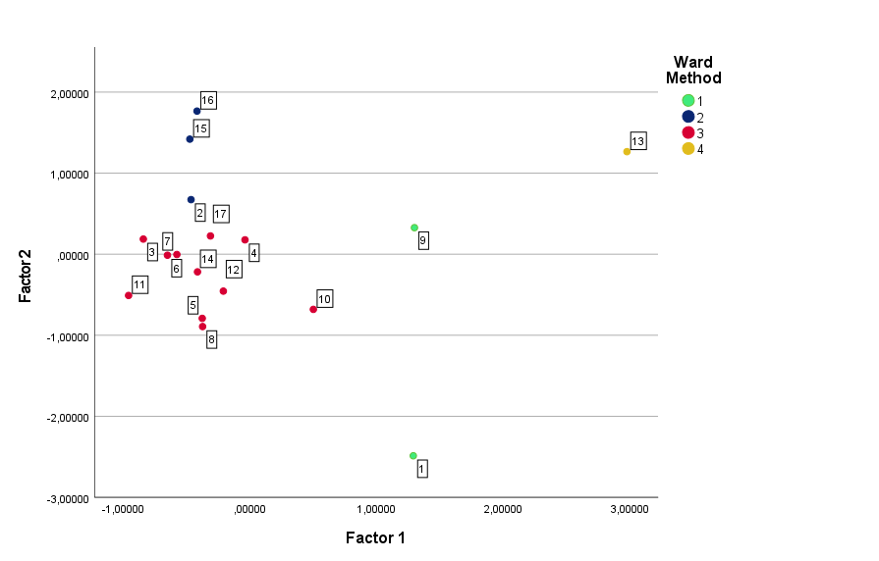

**Figure X.** Figure title.

Source: Xxxx.

**Conclusion**

Xxxxxxxxxxxxxxx xxxxxxxxxxxxxxxxxxxxx xxxxxxxxxxxx xxxxxxxxxxxxxxxx xxxxxxxxxxx xxx xxxxxxxxxxxxxxxxxxxx xxxxxxxxxxxxxxxxxxxxx xxxxxxxxxxxxxxxx xxxxxxxxxxxxxxxxxx xxxxxx xxxxxxx.

**References**

References in APA format.